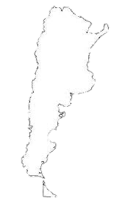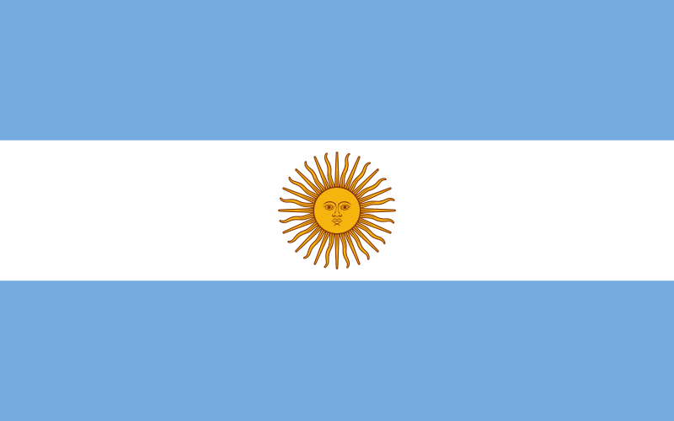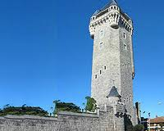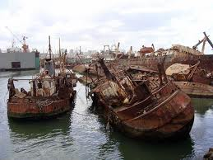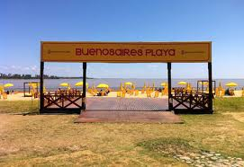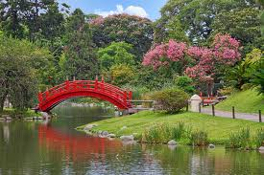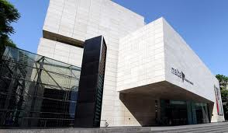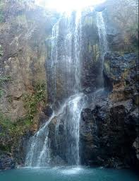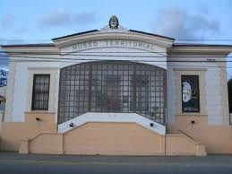

Mi país se llama Argentina.

Está en América del Sur.

Las personas se llaman argentinos.

Un argentine famoso se llama Lionel Messi. (fútbol)

El día independencia de mi país es 9 julio de 1816.

Un dato histórico interesante es Carnaval Porque es un gran evento celebrado en Brasil.

🙞 🙜

By Grant Hilliard

Ushuaia

Buenos Aires

Mar del Plata

🙞 🙜

# Argentina

There are many things to do in the in the beautiful capital of Argentina. You could go to the amazing Malba which is the Latina American Museum of Art. You can also see the Buenos Aires Japanese Gardens which is the largest one outside of Japan. And lastly, the beaches which are equepped with scoccer fields, vollyball courts, and cooling stations.

Mar del Plata is known for its gorgeous beaches. It harbors a ship graveyard two kms off the shore, which is full of half sunken ships that are still visible to this day. Another sight notable is the Torre Tanque which is a medieval looking water tower that is partly a museum.

Ushuaia

Ushuaia is on the southern cost of Argentina. One of the biggest attractions in Ushuaia is the Museo del Fin del Mundo. The Museo del Fin del Mundo also known as the End of the World Museum contains Fuegian history. Ushuaia is using its new system of eco-tourism that encourages people to visit natural places.

Mar del Plata

## Buenos Aires