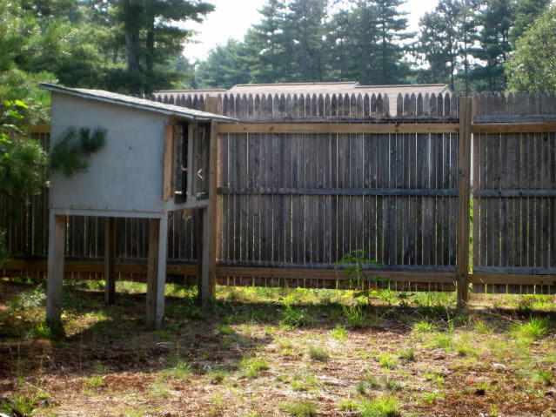
I sit in a cage, alone. I press myself under the little bit of covered shelter I have, as the rain falls down through the leaky roof. The wire floor I live on, makes my feet sore. I stare through the bars of my hutch at the wide, green yard before me. I only wish I could run away. But where would I go? What would I eat? Where would I find shelter? I know I have to stay, but it doesn’t matter anyway. I have no choice, but to stay in my hutch. There is no way out.

My family brings me food and water; they clean my cage as well. My basic needs are all being met. So maybe I shouldn’t complain. But they never talk to me or hold me, or love me. They never stop to stroke my velvet soft fur like they once did. Long ago when I was a baby, they used to pet me. They used to love me.
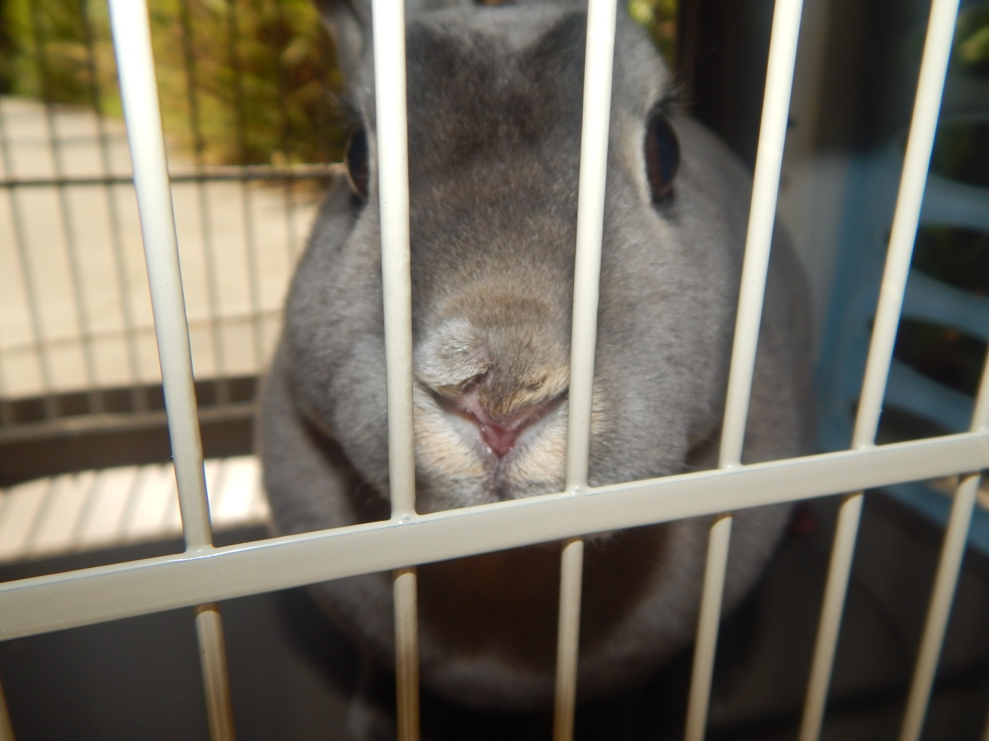

One day, the tall woman in the family, who now takes care of me, walked out of the house and said with frustration, “I’m so done with taking care of this rabbit. I told my husband that Billy was too young to handle the responsibility that comes with having a pet. But he insisted on having a baby bunny in his Easter basket. I’m sorry little bunny, but I’m going to have to take you to the animal shelter”. She sighed. “They’ll find a nice home for you. Hopefully you’ll get more attention than you have here.” She opened the door to my cage, scooped me into her arms and put me in a cardboard box. I was scared and cowered into the corner of the box.
The box was placed on the front seat of the car. I was terrified as the car started with a loud roar. My overgrown nails scratched the slippery cardboard uselessly as I tried to maintain traction every time the car turned a corner. Luckily, the drive was short. The next thing i knew, I felt the box being lifted out of the car. I tried to be very still so she wouldn't drop me. Suddenly we were inside a place where you didn’t have to have ears as good as mine, to hear all the different sounds coming from the other animals in the building.I heard the tall woman say, “My children were given this rabbit for Easter, but…” The other woman sighed unhappily. “It’s okay you don't have to say anymore. We’ll take your rabbit.”One of the volunteers took my box and gently lifted me out. I cautiously looked around at my new surroundings. I was taken into a smaller room where I was wrapped tightly in a towel so that my nails could be cut. Even though the pedicure was scary, the woman was gentle. I knew I could trust her. After my nails had been trimmed, I was brought into another room with many different cages. Some of the cages contained rabbits and some contained other small animals. I was placed into my own cage with fresh bedding, hay, pellets and water. “Welcome,” said a shaggy guinea pig. He told me his name was Gandalf and that the building was called The San Diego Humane Society.
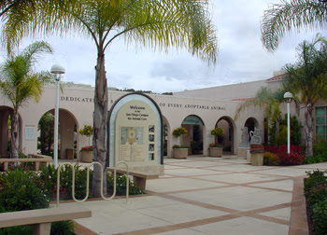

After all of the hospitality I had already experienced, I knew I was going to be okay. One of the people, Gandalf called a volunteer, said, “Ginger has been selected to be part of the Pet-Assisted Therapy program.”
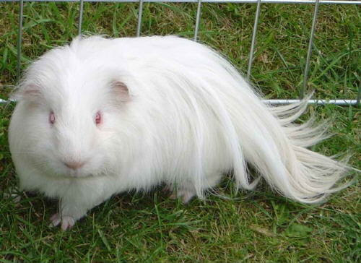
“Do you hear that, Ginger? You get to be an animal ambassador”, squeaked Gandalf. “What an honor!”

I tilted my head in question at what Gandalf had told me. I wondered what it meant to be an Animal Ambassador. “What do I need to do?”, I asked. Gandalf chuckled in response. ”You’ll see”, he said his nose twitching. Soon I realized that being an Animal Ambassador meant being a representative for the San Diego Humane Society. I was brought into classrooms full of children. I would just sit quietly and they would all pet me and ask question after question about rabbits, in general, and about me, specifically. I closed my eyes with pleasure when they would all take turns gently petting my soft fur. Finally, I was getting the attention that I had been craving for so long.
It’s been about a month since I first started the Animal Ambassadors program. While living at the Humane Society, I watched many animals come and go including my good buddy Gandalf. I have enjoyed my time at the Humane Society and doing pet therapy as an ambassador, but still I couldn’t help longing for a home of my own.
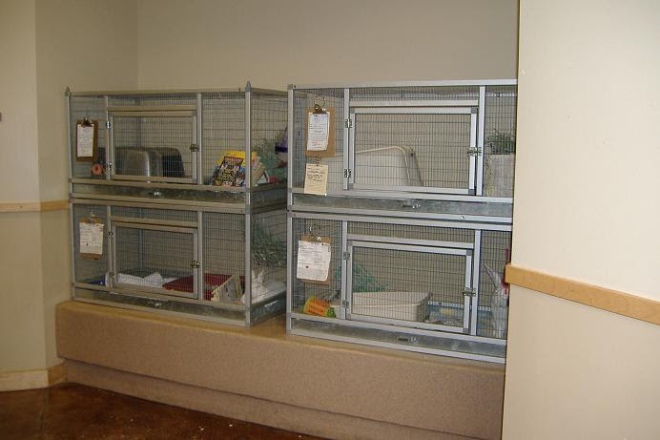

Then one day I was sitting in my cage, chewing on some hay, when I see a young girl and her mom walk in. The girl was tall and thin with curly hair, green eyes and a friendly , shy smile. Soon they walk towards me. They are talking about something called “Adoption”. I twitch my ears back and forth, trying to understand what they were saying. As they look at me, the girl’s face lights up with happiness. “There she is mommy! That’s Ginger! She’s the one!” “Me? they were talking about adopting me?” I hopped to the front of my cage and tried to look as cute as possible. I was filled with sadness, when the girl’s mom put her arm around her shoulders and gently leads her away.
Imagine my surprise when after a few days, I find myself sitting in a car again, but this time I am next to the girl with curly hair. I find out her name is Charli. She tells me this and many other things as her mom drives the car. She can’t keep her hands off me! But I admit, I love the affection. Charli already makes me feel safe and loved. Once we arrived home, I see that it’s the home that I had longed for my whole life. I have a comfortable pen with all of the comforts I had grown accustomed to while living at the Humane Society, but it was much larger. I even got to go outside each night, around twilight, to hop around the yard. I got so excited at having the opportunity to hop around the large, grassy yard, I jumped really high and kicked my feet in mid air. This made Charli laugh with delight.

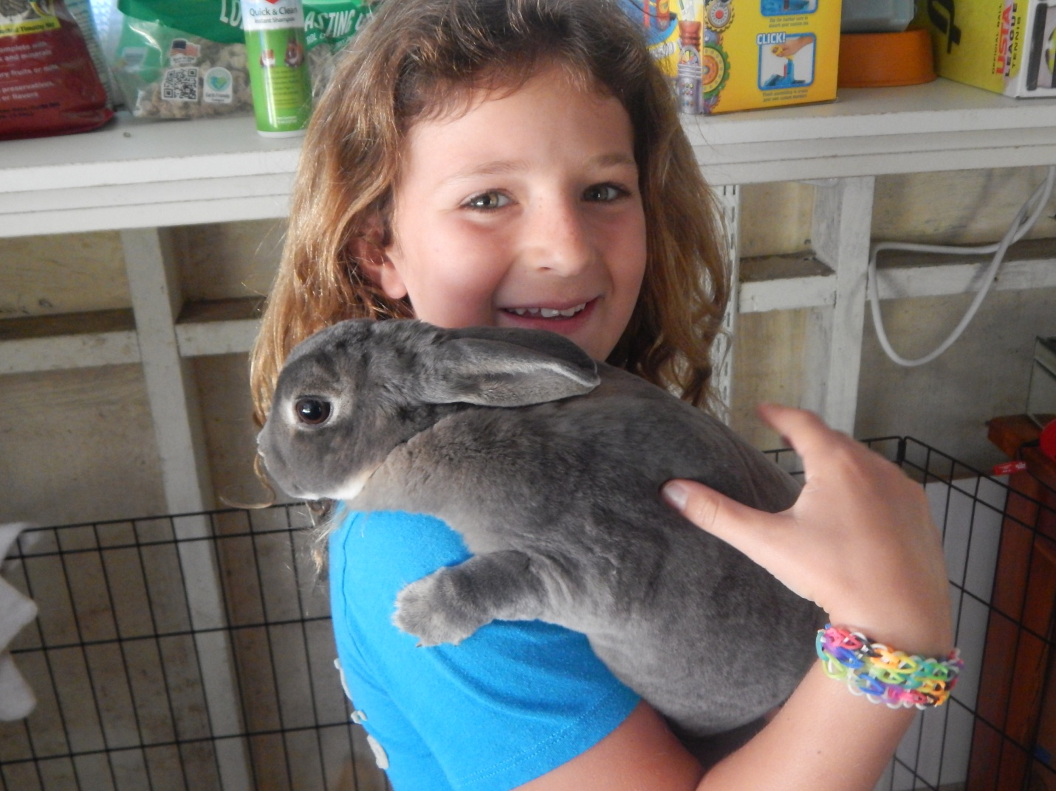
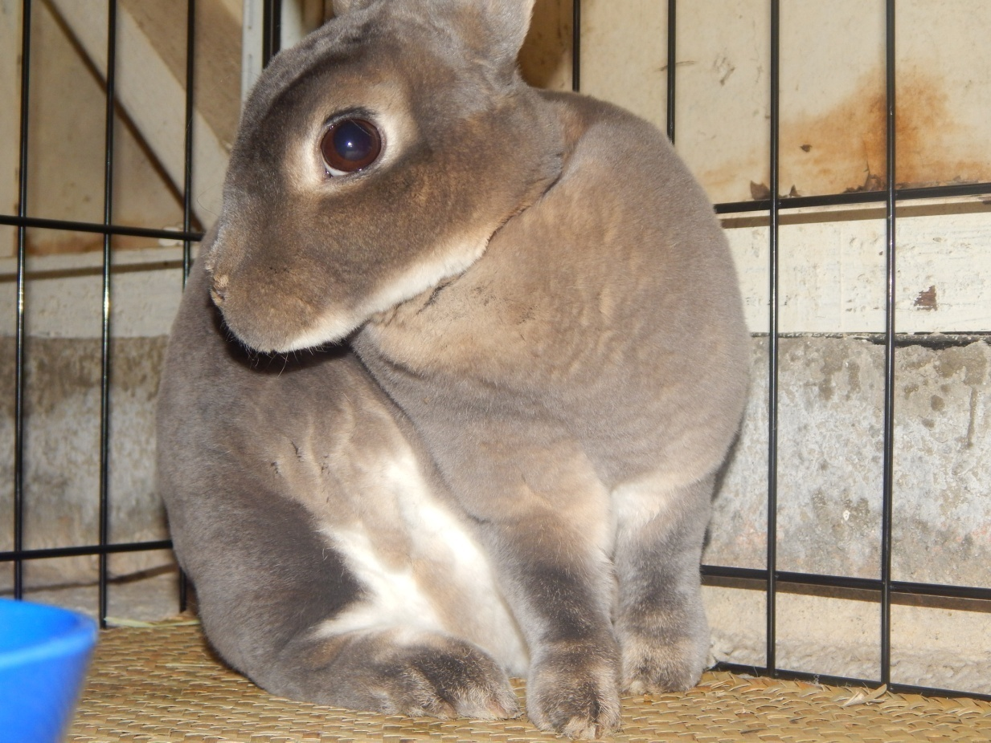
“Look, Charli. She’s dancing! She must be really happy!”, her mom said. “I’m changing her name to Twilight”, Charli said. “Since she likes to dance at twilight.” Finally, I am happy. I have a new name and I know I am not just a gift, given to a little kid for Easter. Now I am a pet that is part of the family. I know that Charli will love and cared for me for the rest of my life. I am finally home.

